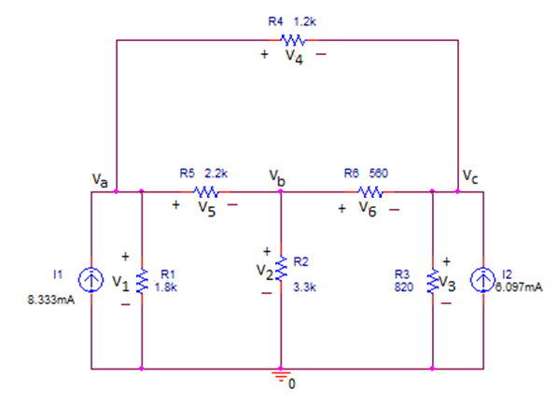

1. Find the node voltages Va, Vb, and Vc
2. Use the node voltages to find V4, V5 and V6
3. What is the power supplied or absorbed by each source I1,I2? Explain.
4. What is the power absorbed by R1 and by R4?